

Practical: 4 | Implementation and Time analysis of factorial program using iterative and recursive method

Aim: To Implement and Time analysis of factorial program using iterative and recursive method

Algorithm:
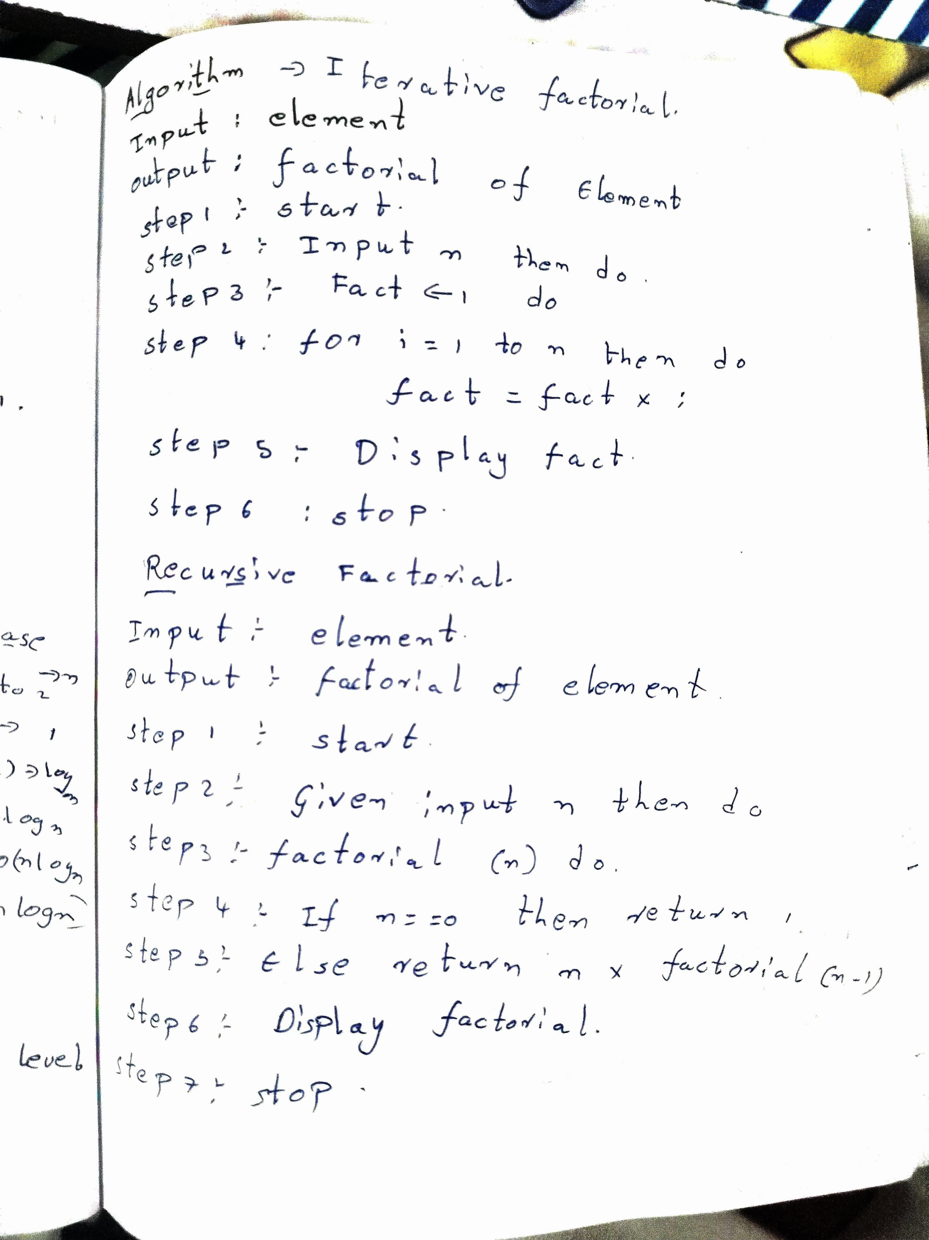

Program: Iterative Code
#include<iostream> using namespace std;
int factorial(int n){ int fact = 1;

for(int i = 1; i <= n; i++){ fact = fact * i;
}
return fact;
}
int main(){ int n;

cout<<"enter the number "; cin>>n;

cout<<"factorial of the number is: "<<factorial(n);

return 0;
}

Recursive Code #include<iostream> using namespace std;

int factorial(int n){ if(n==0){
return 1;
}
else{
return n*factorial(n-1);
}
}

int main(){ int n;
cout<<"enter the number "; cin>>n;
cout<<"factorial of the number is: "<<factorial(n); return 0;
}

Output:

Iterative Method
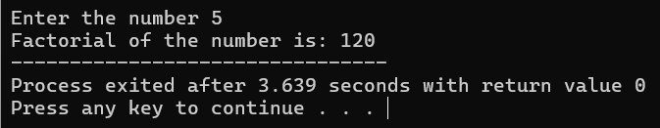

Recursive Method
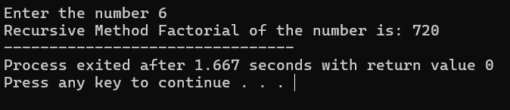

Time Complexity:

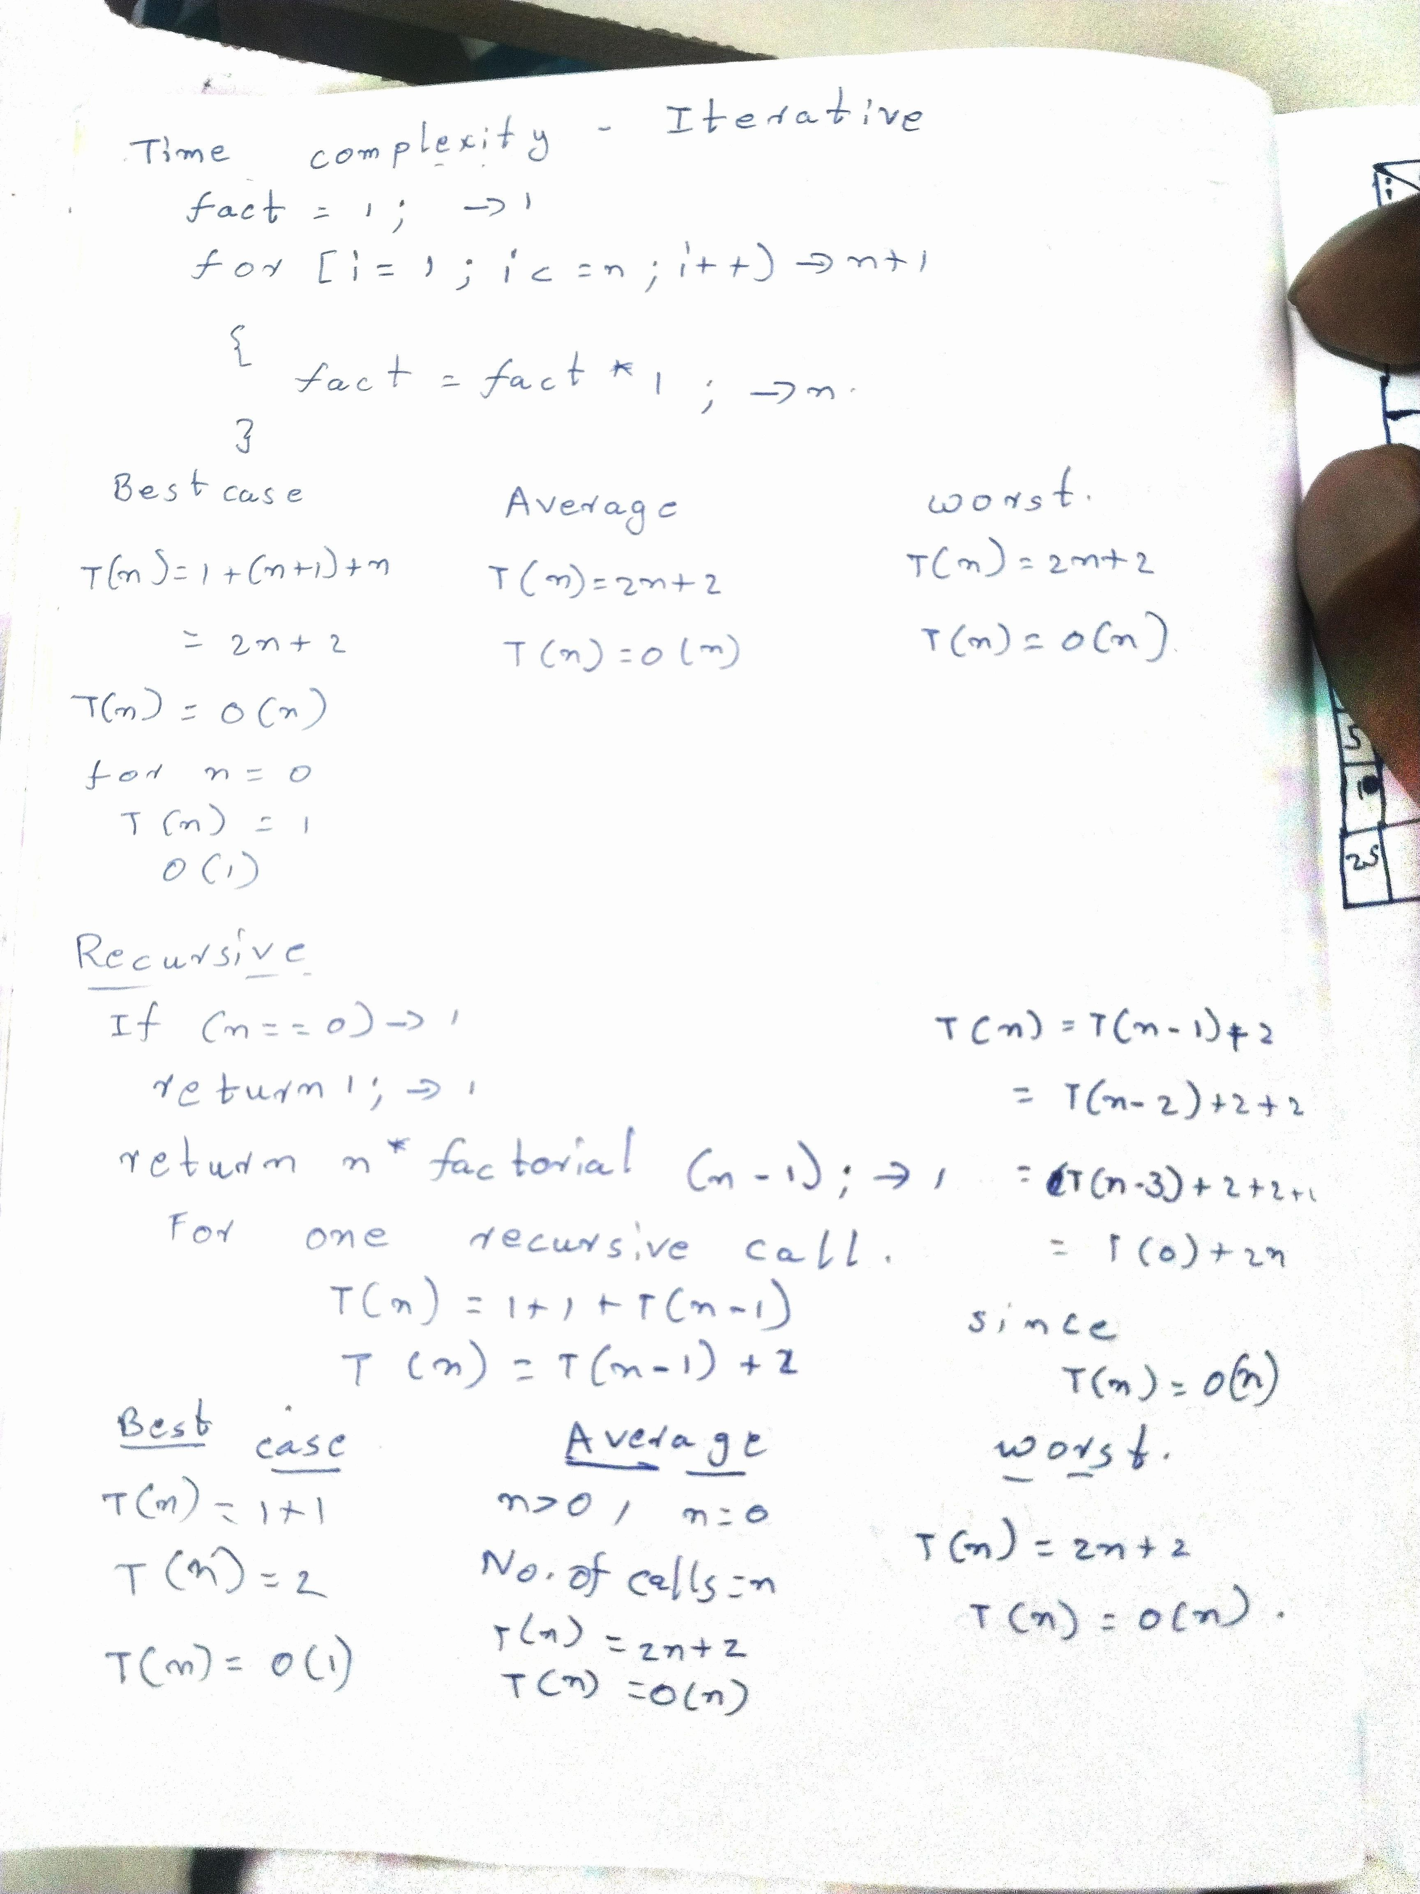

Conclusion:
Hence, the Max-Heap Sort algorithm was successfully implemented and executed. It was observed that Heap Sort gives a time complexity of O(nlogn) in the best, average, and worst cases. It is an efficient sorting technique and works well for sorting large sets of data.

